Research Information Sheet
How do unmet health and social needs impact individuals prior to, during and after a custodial prison sentence in England?

You are invited to be part of a research study. This information sheet tells you about the study and how you can be involved. You can ask the researcher questions before deciding if you would like to take part. You do not have to take part.
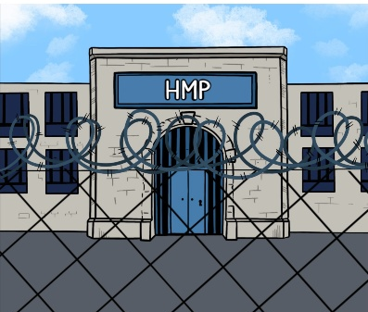
What the research is about?
The research is about people involved in the criminal justice system. This means the police, the courts, probation and prisons.
People involved in the criminal justice system are more likely to have found things in life to be harder. This might be to do with their health, being homeless, with money or at school. They may have also found it hard to get the help they need.
This research would like to know about things that have been hard in people’s lives and will ask about before, during and after being in prison. This information will help us to understand what people need and get ideas on how people can be helped.

What would I have to do if I take part?
You will meet with the researcher at the university or the offices of somewhere you receive support if they agree.
The researcher will ask you about your life. This will include things about your health, housing or experiences growing up.
You do not have to tell the researcher anything you do not want to.
You can also draw your life experiences on paper. You do not have to do this.

The conversation will be voice recorded to make sure nothing you say is forgotten. The recording will be deleted after the researcher has written down what you said.
This will take about 2 hours. This can be one meeting or two meetings.
You will be given a £20 gift card. If you come to the university you may have to pay travel costs. The researcher may be able to give you an extra gift card if you have to pay travel costs. The researcher will let you know the amount of this extra gift card before the meeting. We cannot give you cash.
Why have I been invited to meet with the researcher?
You have been invited because:
· You have been in an adult prison in England or Wales
· You are 18 years old or older
· You do not get section 117 aftercare funding
Do I have to take part?
No. You decide whether to take part.
Are there any benefits of taking part?
There are no direct benefits to taking part. Taking part in the study will help us understand what people, who are in contact with the criminal justice system, need.
Are there any risks of taking part?
There are no physical risks to taking part.
You will be asked about your life, and some people might find this upsetting. You decide what you want to talk about. You do not have to tell us anything you do not want.
If you do become upset, we can stop the conversation. You can decide whether to carry on talking. We can contact a friend, family or organisation to support you if you want.
The researcher will call you 2 days after the conversation to see if you need any support. You can also get support from:
Organisations you can contact for support
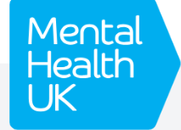  Mental health UK: Downloadable resources https://mentalhealth-uk.org/help-and-information/downloadable-resources/ |   Samaritans: telephone or email support  Phone – 116 123  email address jo@samaritans.org
  Shout: text based support, if you would prefer not to talk  Text 85258 |   Mind: telephone support  Phone 0300 102 1234

What happens with what I tell you?

Newcastle University must keep your information safe. Only people who need to contact you from Newcastle University will be able to see your personal details.
After the conversation, the recording of what you have said is written down, and anything that could identify you is removed. The research team will read the written version that does not identify you. People who have been in prison are helping with the study. They will only read small parts of the written version so they can’t identify you.
Your information will be kept safe in a locked drawer and on a password protected computer at Newcastle University.
The things we find out from this study might be shared in reports, publications and at conferences. We might use some of the words you have said in these. No one will be able to identify you from these.
If you do any drawing, you can decide if this is shared or not. If any drawings might identify you, we will not use them.
We will keep information that identifies you until the end of the study. This is the consent form and your contact details. The written copy of what you said, and artwork that doesn’t identify you, will be kept for at least 10 years.
The written version, that cannot identify you, may be shared with other universities, the NHS or other services doing research. They will not be able to contact you or know that the information is from you. If you do not want this to be shared, we will not share it. You will be given the written copy of what you said with details identifying you removed. The research can go through this with you. You can then decide if you want this shared.
You can find out more information about how Newcastle University uses your information here: https://www.ncl.ac.uk/data-protection/data-protection-policy/
You can also ask Newcastle University what information they have about you here: https://www.ncl.ac.uk/data-protection/access-personal-data/
Will you tell anyone I took part?
We will not tell anyone you took part unless we are worried about your safety or the safety of someone else. If you tell us something about breaking the law we would only tell someone if we were worried about your safety or the safety of someone else. If we are worried, we would talk to you about this. We may need to tell someone who can help you.
What if I change my mind?
If you take part, you can change your mind within 4 weeks. If you do change your mind, you can contact the researcher. The researcher will delete any information about you.
Has this study been given ethical approval?
This study has received ethical approval from Newcastle University Ethics Committee on 04/05/2026, reference 71321.
Who can I get in touch with if I want to talk about the study?


You can contact the researcher, Lisa Moseley:
Email: l.moseley3@newcastle.ac.uk
Telephone: 07375 753401
You can also scan the QR code and ask Lisa to contact you.
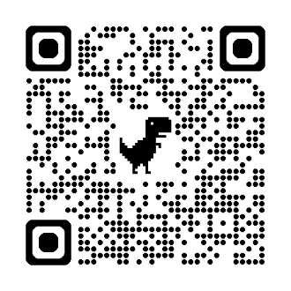
If you have a complaint, you can contact Lisa Moseley. You can also contact the research supervisor, Steph Scott:
Email: steph.scott@newcastle.ac.uk
If you wish to raise a complaint on how your personal data is handled, you can contact the Data Protection Officer, Maureen Wilkinson, who will investigate the matter, Maureen Wilkinson:

Email: rec-man@ncl.ac.uk

If you are not satisfied with their response you can complain to the Information Commissioner’s Office (ICO): https://ico.org.uk/

